System info commands.
- Display the kernel name.
- Display the current date and time.
- Show your machine name.
- Display the version and release of the kernel.
- How to check the size of a directory?
- Display the OS name.
- Print the current running shell.
- How to check available memory?
- Display the current username.

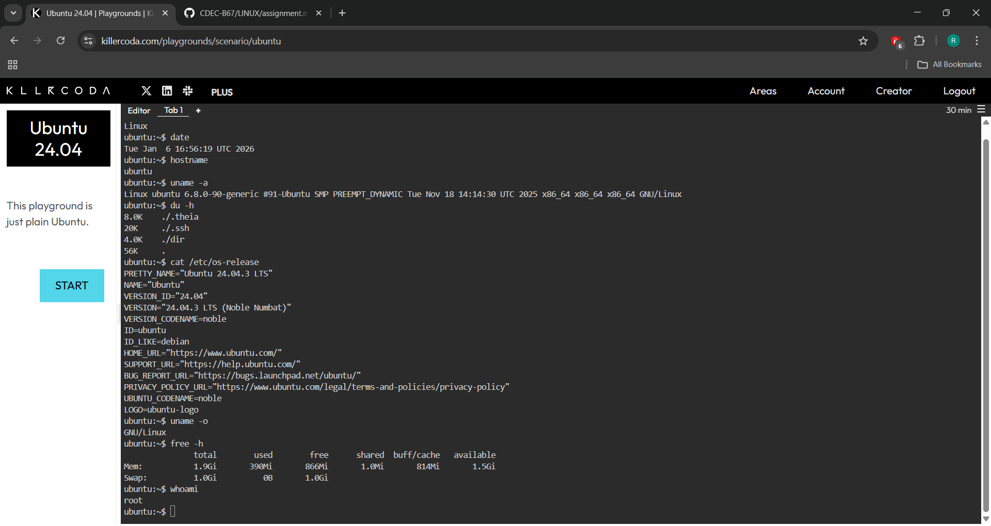

File and Directory Management
- Create a directory with the name /practice.
- Create a file in the /practice directory named task2.txt.
- Write 10 lines of data in task2.txt using the vi/vim editor (topic: India).

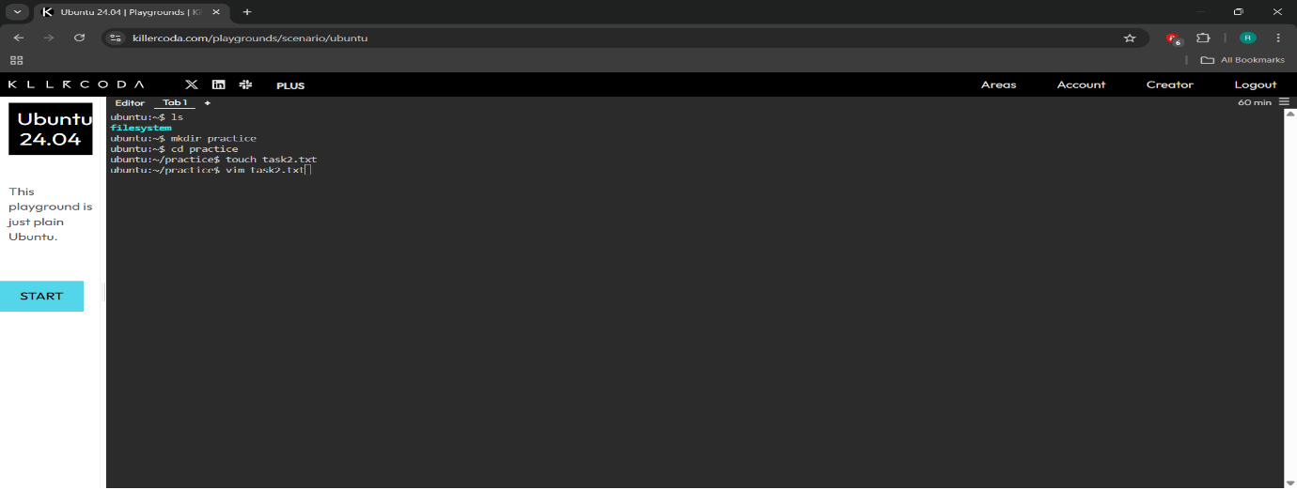

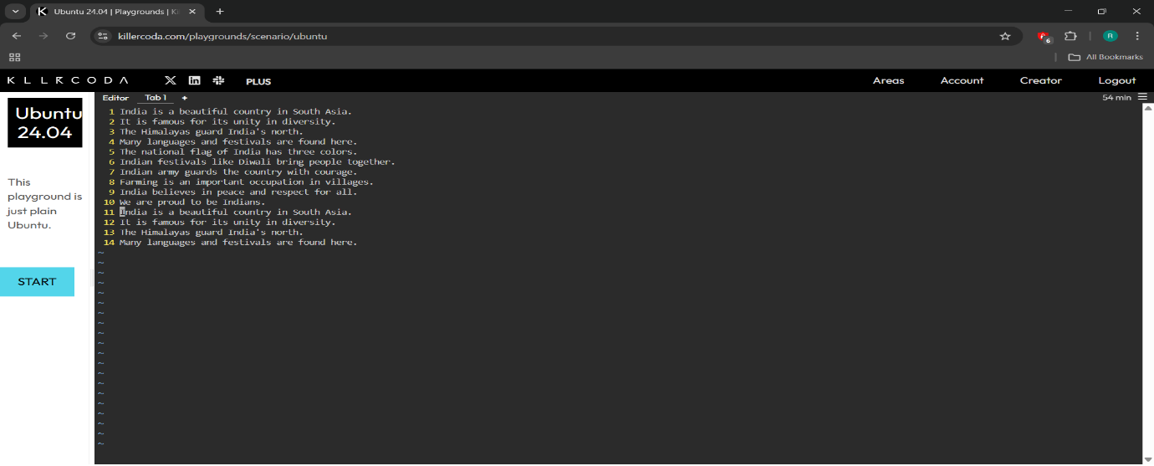

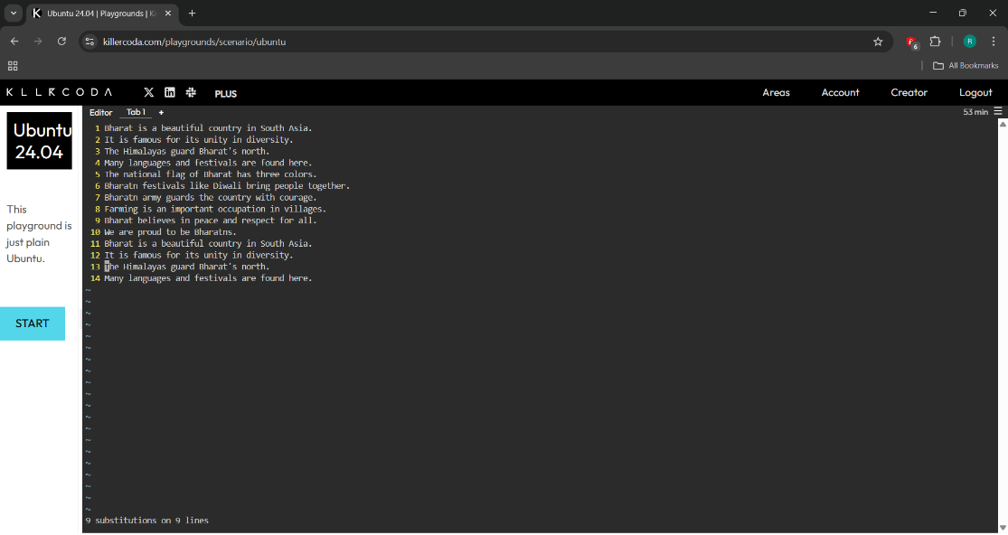

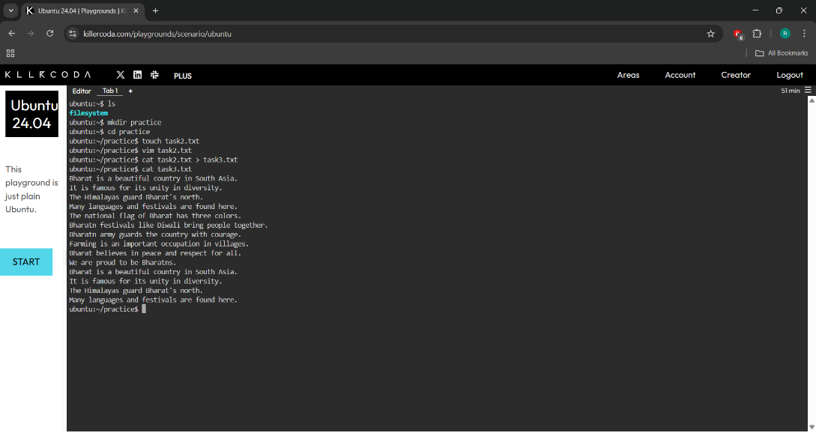

$$\text{User and Group Management}$$
- Add users: raju, sham, and babubhaiya; assign passwords to them.
- Change the user ID of raju to 4002.
- Change the user ID of sham to 4003.
- Create a group named herapheri.
- Assign a password to the herapheri group.

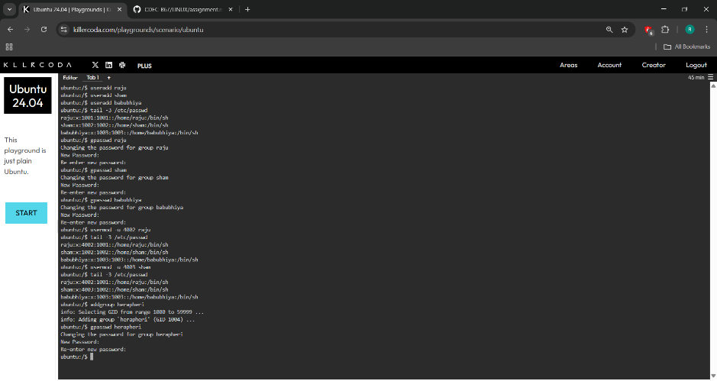

- Add raju sham, and babubhaiya to the herapheri group.
- Make babubhaiya the admin of the herapheri group.
- Remove sham from the herapheri group.

